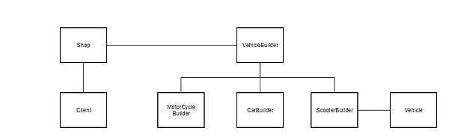

* The client goes to the shop, which is the director. The shop (director) will then notify the VehicleBuilder whenever a part of the product should be built. In this case, the VehicleBuilder will either build a Motorcycle, a Car or a Scooter, which will then create the vehicle.